Jackson Gross

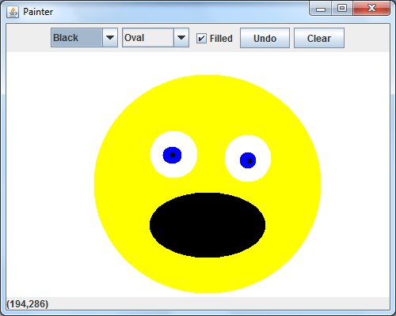

// GCS Exercise 14.17 Solution: Painter.java

// Test application to display a DrawFrame

import javax.swing.JFrame;

public class Painter

{

public static void main(String[] args)

{

DrawFrame application = new DrawFrame();

application.setDefaultCloseOperation(JFrame.EXIT_ON_CLOSE);

application.setSize(500, 400);

application.setVisible(true);

} // end main

} // end class Painter

/**************************************************************************

* (C) Copyright 1992-2014 by Deitel & Associates, Inc. and *

* Pearson Education, Inc. All Rights Reserved. *

* *

* DISCLAIMER: The authors and publisher of this book have used their *

* best efforts in preparing the book. These efforts include the *

* development, research, and testing of the theories and programs *

* to determine their effectiveness. The authors and publisher make *

* no warranty of any kind, expressed or implied, with regard to these *

* programs or to the documentation contained in these books. The authors *

* and publisher shall not be liable in any event for incidental or *

* consequential damages in connection with, or arising out of, the *

* furnishing, performance, or use of these programs. *

**************************************************************************/